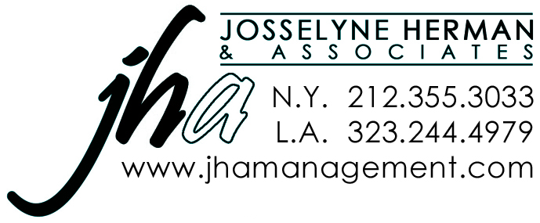
Warren Kelley The Jim Flynn Agency
sag-aftra aea 212-868-1068
www.warrenkelley.com jimbbf@earthlink.net

Film / Television
BOARDWALK EMPIRE David Hewson – Recurring [Dir. Allen Coulter]
BIRDMAN (w/ Michael Keaton) Riggan’s Dresser – Supporting [Dir. Alejandro Gonzales Inarritu]
HOUSE OF CARDS “Glen Beck” – Co-Star [Dir. David Fincher]
LAW & ORDER: SVU George Overby – Co-Star [Dir. Jonathan Herron]
THE OTHER GUYS (w/ Will Ferrell) NYSE Official - Supporting [Dir. Scott McKay]
LAW & ORDER: SVU ER Dr. Turk – Co-Star [Dir. Aaron Lipstadt]
CHAPPELLE’S SHOW Music CEO - Co-Star [Dir. Todd Broder]

Off Broadway
THE VOYSEY INHERITANCE Trenchard Voysey Mint Theatre Co.
ENGAGING SHAW (NY Times Critics Pick) George Bernard Shaw Abingdon Theatre Co.
THE AHHH FACTOR (by Bruce Graham) Robert The Clurman
ELVIS AND JULIET (w/ Fred Willard) Owen Heathcliff Jones Abingdon Theatre Co.
STRINGS (w/ Keir Dullea) Rory 78th St. Theatre Lab
RIVER’S END (w/ Phyllis Somerville) Kent, et. al NYMF
BAKER STREET (w/ Simon Jones) Lestrade York Theatre Co.

Regional Theatre (Partial List)
33 VARIATIONS Beethoven Festival Stage of Winston-Salem
OLIVER! Fagin Arkansas Shakespeare Theatre
KING LEAR Duke of Albany Arkansas Shakespeare Theatre
BOOKENDS (World Premiere / by M.J. Feely) Elia Kazan Walnut Street Theatre
THE GIFT (World Premiere / by Will Stutts) Truman Capote Walnut Street Theatre
TO KILL A MOCKINGBIRD Atticus Finch Arrow Rock Lyceum Theatre
THE UNEXPECTED GUEST (by Agatha Christie) Title Role Arrow Rock Lyceum Theatre
BOEING BOEING Robert Arrow Rock Lyceum Theatre
THE FOREIGNER Charlie Baker Fulton Theatre
A LITTLE NIGHT MUSIC Fredrik Egerman Orlando Shakespeare Theatre
THE COMEDY OF ERRORS Antipholus Orlando Shakespeare Theatre
LOVE’S LABOUR’S LOST Boyet Orlando Shakespeare Theatre
A TUNA CHRISTMAS Thurston / Bertha / et. al Actors Theatre of Louisville
THE PRODUCERS Roger De Bris Riverside Theatre
ART Yvan Riverside Theatre
SLEUTH Milo Tindle Riverside Theatre
OPUS Dorian Ensemble Theatre of Cincinnati
MOONLIGHT AND MAGNOLIAS David O. Selznick Ensemble Theatre of Cincinnati
THE BEST MAN (w/ Billy Campbell & Celia Weston) Sheldon Marcus Cape Playhouse
THE MISER La Fleche Pioneer Theatre Co.
A PENNY FOR A SONG (by John Whiting) Samuel Breeze Pioneer Theatre Co.
MISALLIANCE Percival Pioneer Theatre Co.
SYLVIA Greg Florida Studio Theatre
TWO JEWS WALK INTO A WAR (by Seth Rozin) Zeblyan Florida Studio Theatre
ABIGAIL’S PARTY (by Mike Leigh) Laurence Two River Theatre Co.
NOISES OFF Freddy Two River Theatre Co.
HOUDINI Florenz Zeigfeld Goodspeed Opera House
DEAR WORLD (w/ Sally Anne Howes & Georgia Engel) The President Goodspeed at Chester
LEND ME A TENOR Saunders Arts Center of Coastal Carolina
THE FULL MONTY Harold Arts Center of Coastal Carolina
EVIE’S WALTZ (by Carter W. Lewis) Clay New Jersey Repertory Co.
CHARACTER ASSASSINS (by Charlie Schulman) Simon Frank New Jersey Repertory Co.
BACH AT LEIPZIEG Georg Lenck Florida Stage
LONELY PLANET (by Steven Dietz) Carl Florida Stage
BELOW THE BELT (by Richard Dresser) Dobbit Florida Stage
BLITHE SPIRIT Charles Condomine River Rep at Ivoryton
DINNER WITH FRIENDS Gabe River Rep at Ivoryton
THE LADIES MAN (by Feydeau & Charles Morey) Dr. Hercule Molineaux Sierra Repertory Theatre
SCOTLAND ROAD (by Jeffrey Hatcher) John Seven Angels Theatre
ALL MY SONS Frank Emelin Theatre
ZORBA (w/ Anita Gillette & Ron Holgate) Konstandi North Shore Music Theatre

Training - MFA Temple University, Michael Howard Dialects - British, Cockney, Irish, Russian, French, German, etc., Baritone
Directors - Kate Alexander, Gabriel Barre, SuzAnne Barabas, Allen Cornell, Drew Fracher, Jonathan Fox, Quin Gresham,
Michael Evan Haney, Jim Helsinger, Tom Markus, Charles Morey, DJ Salisbury, Jenn Thompson, Russell Treyz, Steve Umberger
Awards / Nominations – BroadwayWorld Florida Award, New York Innovative Theatre Award, Connecticut Critics Circle [4 times], Cincinnati Entertainment Award [2 times], Cincinnati Acclaim Award, Florida’s Carbonell Award

